 **Project Report**

* 1. **Overview**
  + **Here is the android app for Adaptive Mail.It is used to exchange information between user and another user.** It can be distributed to lists of people as well as to individuals.
  1. **Purpose**
  + An application makes it easy to communicate with people anywhere in the world by sending and receiving messages in real time. We can easily sendthe messages and store the document in easy way while using this app.

2. **Problem Definition & Design Thinking**

2.1 Empathy Map

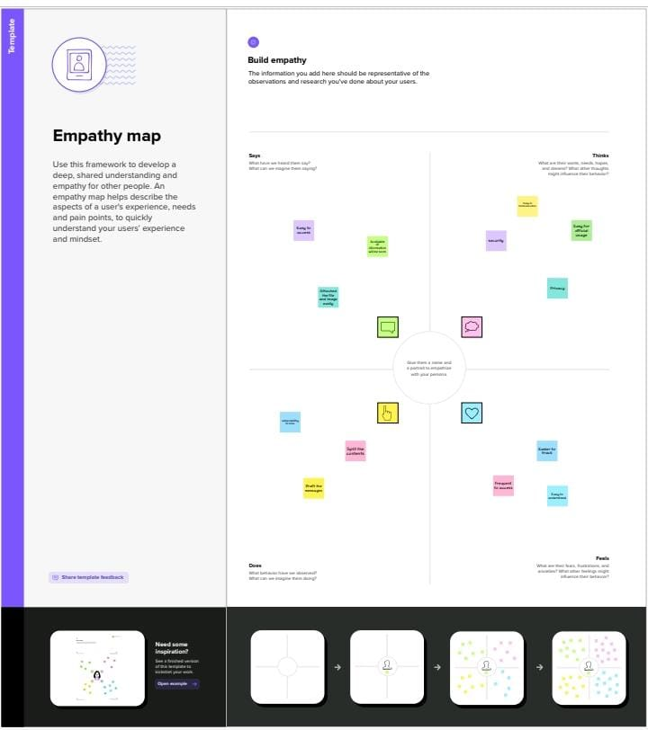

**2.2 Ideation & Brainstorming Map**



**3.Result**

Output

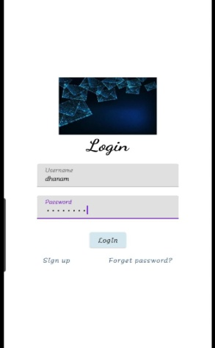   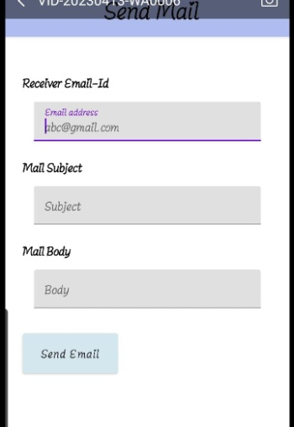 

**4 ADVANTAGES & DISADVANTAGES**

Advantages :

* It provides faster and easy mean of communication.
* It is effective and cheap means of communication
* This is very easy to filter.
* E-mail is not just only for textual message. One can send any kind of multimedia within mail..
* It is secure and reliable method to deliver our message.

Disadvantages

* It is source of viruses.
* These spam mails can fill up inbox and to deletion of these mail consumes lot of time.
* It is informal method of communication.
* To be updated, user have to check inbox from time-to-time.

**5 APPLICATIONS**

* Emails are used for the purpose of communication, such as communicating with instructors and professors, keeping in touch with friends, requesting information from other people or businesses, applying for scholarships, jobs and internships.
* Emails are the best form of communicating with a person
* Who is hard to get using other forms of communication such as telephone.

**6 CONCLUSION**

* The app provides a better and more flexible system.
* Developed with the latest technology in the way of providing a reliable system.
* The main advantage of the system is instant messaging, real-world communication, added security, group chat, etc.

**7. FUTURE SCOPE**

* It provides sensitivity to the client and adapts well to the future spam techniques.
* It considers a complete message instead of single words with respect to its organization.
* It increases Security and Control.
* It reduces IT Administration Costs.
* It also reduce Network Resource Costs.

**8 . APPENDIX**

Source Code

https://github.com/DhanamSenthilkumar/Adaptive-mail

44123r